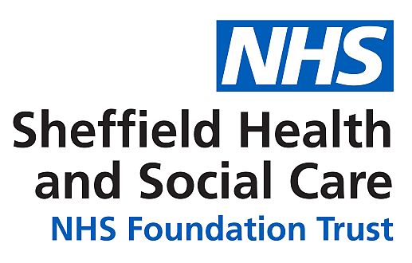

Sheffield Psychosexual Therapy Service
The Fitzwilliam Centre
143-145 Fitzwilliam Street
Sheffield
S1 4JP

Tel: 0114 271 6979
Fax: 0114 271 8693
Email: psychosexualtherapyservice@shsc.nhs.uk
Website: https://www.shsc.nhs.uk/services/sheffield-psychosexual-service

Our waiting list currently stands at approximately 4-6 months. We understand that accessing support when you need it is incredibly important, and we sincerely apologise for your wait.

Please find below a list of other services that you may find helpful to offer support while you wait to be seen by the service:

College of Sexual and Relationship Therapists – www.cosrt.org.uk
Sex and Love Addicts Anonymous – www.slaauk.org
Sex Addicts Anonymous – www.saauk.info
Relate – www.relate.org.uk
Institute of Psychosexual Medicine – www.ipm.org.uk
Vulval Pain Society - www.vulvalpainsociety.org/vps/

You do not need to do anything if you wish to remain on the waiting list, however, if you do want to be removed from the waiting list please contact the service preferably by emailing us at psychosexualtherapyservice@shsc.nhs.uk or calling us on (0114) 2716979 between 09:00 and 17:00 Monday to Friday. If we are unable to answer, please leave a message for us on the voicemail system.

We also understand that during the waiting period, your personal details may change including your current address, telephone numbers or GP practice. If you do happen to have changed any of your personal details, we would be grateful if you could inform us immediately, ideally by emailing psychosexualtherapyservice@shsc.nhs.uk. If we do not have the correct telephone numbers or address for you, it may prevent us from being able to offer you an appointment.

Yours sincerely,

Sheffield Psychosexual Therapy Service
The Fitzwilliam Centre

