Expert by Experience
Accessible Job Application Form
Project Lead: Inpatient Cultural Change Programme

If you would like more information about this job or you need some help filling in the job application form, please email:
engage@shsc.nhs.uk
Your name

Your contact details
Email address if you have one

What is the best phone number to call you on?

Address including postcode:

Internal / External:

Date of Birth:

Gender:

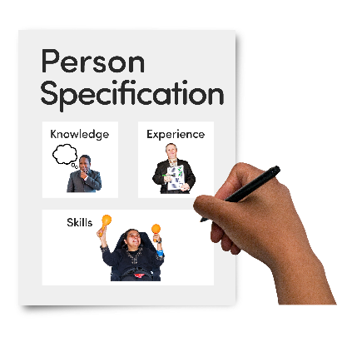
You need to look at the Person Specification and Job Description You have to be able to do all the things in the person specification.
They will tell you what knowledge, skills and experience you need for the job.
To apply for this job, you need to have lived experience of using services or being a family member or carer of someone who has used SHSC services.
Please note that you can still be using our services and apply for one of the roles.

Do you or someone you know use SHSC services
Yes or No
Have you or do you still use SHSC services?

Yes or No
Are you a family member or carer of someone who uses or has used SHSC services?

Please tell us why you want to do this role and the things you are good at.

Experience
Experience is work, training or anything else that you are doing now or have done.
Please tell us in the box below about any jobs and other experience that will help you do this job:

Education
This can include training courses and certificates. Please tell us in the box below about any training courses and certificates that you have, and any schools or colleges you have been to.
Reference

We need references so that we can talk to people who know you well.
A referee is a person who knows you well but is not a family member or friend.

They could be:

A college or school tutor
A work coach
Someone who supports you

Someone you have worked with
Your care co-ordinator

Please can you give us the name of 1 person we can contact for a reference?

Name

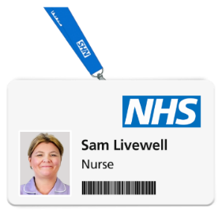

Job Title

Email

Telephonemail

If you get an interview, it will be over the phone or on Microsoft teams. Do you need support if you get an interview?
Yes No

Please tell us about the support you need in the box below:

