Risk Assessment for Bed Base/Mattress in Seclusion
Guidance and record keeping for inpatient staff: -

All mattresses in seclusion suites and in bedrooms are to Crib 7 specification. This meets the necessary fire requirements whilst maintaining some of the potential pressure relief requirements.

As outlined in the Trust’s Use of Seclusion Policy and the criteria identified within the Mental Health Code of Practice [Chapter 26.109], all seclusion rooms should have limited furnishings which should include a bed, pillow, mattress, and blanket or covering. This is to support comfort and aid sleep of the service user in the room.

As standard, all seclusion suites will come with a thick bed base/mattress, as shown in Figure 1:

Figure 1: Standard Seclusion Suite Bed Base/Mattress
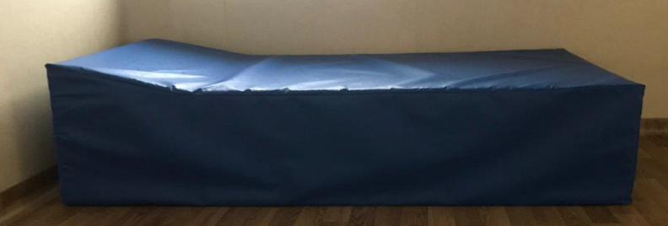

All seclusion rooms will have the bed base/mattress readily available in the room for use at the point of entering seclusion unless a recorded risk assessment has indicated this is not safe and a floor type mattress needs to be used. It is expected this will be in exceptional circumstances. The floor type mattress, in this event, would be the service users mattress from their bedroom.

If during seclusion the bed base/mattress becomes a risk, this can be replaced by the standard bedroom mattress from the service user’s bedroom. This again should only be in exceptional circumstances and be supported by a recorded risk assessment. If a floor type mattress (one from own bed, see Figure 2) is used then this should be reviewed at every review schedule to consider if the bed base one can be re-introduced.

Where both the bed base/mattress and/or the service user individual bedroom mattress are assessed as a risk then an alternative will need to be discussed with the matron or relevant other out of hours to establish a further alternative.

It is imperative that service users are as comfortable as possible whilst in seclusion and that any alternative from the bed base/mattress is clearly risk assessed

Figure 2 : Standard Bedroom Mattress
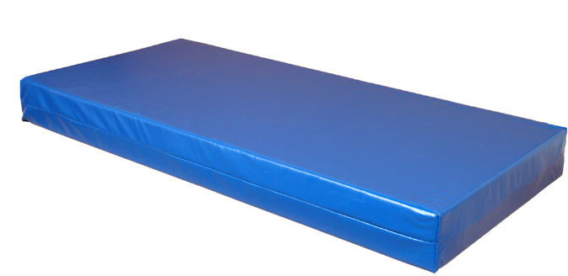

Risk assessment – THIS IS A WORKED EXAMPLE

To be added to service user record

Date and time of assessment:

Assessor undertaking risk assessment: (Name and designation)

Overview of risk assessment - include all presenting risks (relating to service user and seclusion suite, particularly in relation to depth of mattress to use). Please also consider if there is a risk of the service user damaging the alternative mattress (i.e. chewing, picking) and whether the alternative may require further mitigation and review of use:

Example one
No risks identified with XXX having the bed base/mattress whilst in seclusion. Staff on her observations and doing nursing and medical reviews will review this to ensure this remains safe to use.
Example two
XXX is very distressed and angry about being in seclusion and there are concerns that she may use the bed base/mattress to climb or block the entrance to the seclusion room, making it difficult for staff to enter or view her. On this basis the risk assessment indicates that XXX is to be provided with the mattress from her bedroom and that this will be reviewed at each nursing and joint review to see if the bedbase mattress can be reintroduced. Family and advocacy are to be informed of this and this will be reflected in her seclusion careplan. An incident form will be completed to report the need to use a floor type mattress. There are no risks indicated with using the mattress from her bedroom in terms of safety however it is noted that this is likely to be less comfortable as it is floor based
Example three
Following being in seclusion for the last 2 hours XXX has tipped the bed base/mattress onto its side and is hiding behind it making observations of her safety and physical state very difficult. Discussed at part of MDT and agreed for the next few hours the seclusion bed base/mattress will be replaced with her bedroom mattress which is floor based. This will be reviewed at each nursing and joint review. Family and advocacy are to be informed of this and this will be reflected in her seclusion careplan. An incident form will be completed to report the need to use a floor base type mattress.

Decision on mattress to provide in seclusion room:

Keep standard seclusion room bed/base mattress

Use alternative mattress i.e. bedroom mattress

Rationale for any other alternative to bedroom mattress used

Where an alternative mattress has been used, there should be regular reviews throughout seclusion period to revisit the risk assessment and appropriateness of this. All use of alternative mattresses should be incident reported

Complete and add to service user insight record

Use to inform care plan

Inform service user, family, and advocate

Incident report completed

If an alternative mattress has been moved into seclusion room, this must be Clinell wiped before returning to the bedspace.

Risk Assessment for Bed Base/Mattress in Seclusion

To be added to service user record

Date and time of assessment:

Assessor undertaking risk assessment: (Name and designation)

Overview of risk assessment - include all presenting risks (relating to service user and seclusion suite, particularly in relation to depth of mattress to use). Please also consider if there is a risk of the service user damaging the alternative mattress (i.e. chewing, picking) and whether the alternative may require further mitigation and review of use:

Decision on mattress to provide in seclusion room:

Keep standard seclusion room bed/base mattress

Use alternative mattress i.e. bedroom mattress

Rationale for any other alternative to bedroom mattress used

Where an alternative mattress has been used, there should be regular reviews throughout seclusion period to revisit the risk assessment and appropriateness of this. All use of alternative mattresses should be incident reported

Complete and add to service user insight record

Use to inform care plan

Inform service user, family, and advocate

Incident report completed

If an alternative mattress has been moved into seclusion room, this must be Clinell wiped before returning to the bedspace.

